Organization profile page

SEETechnology

The following image shows the wireframe mockup of the organization profile page:

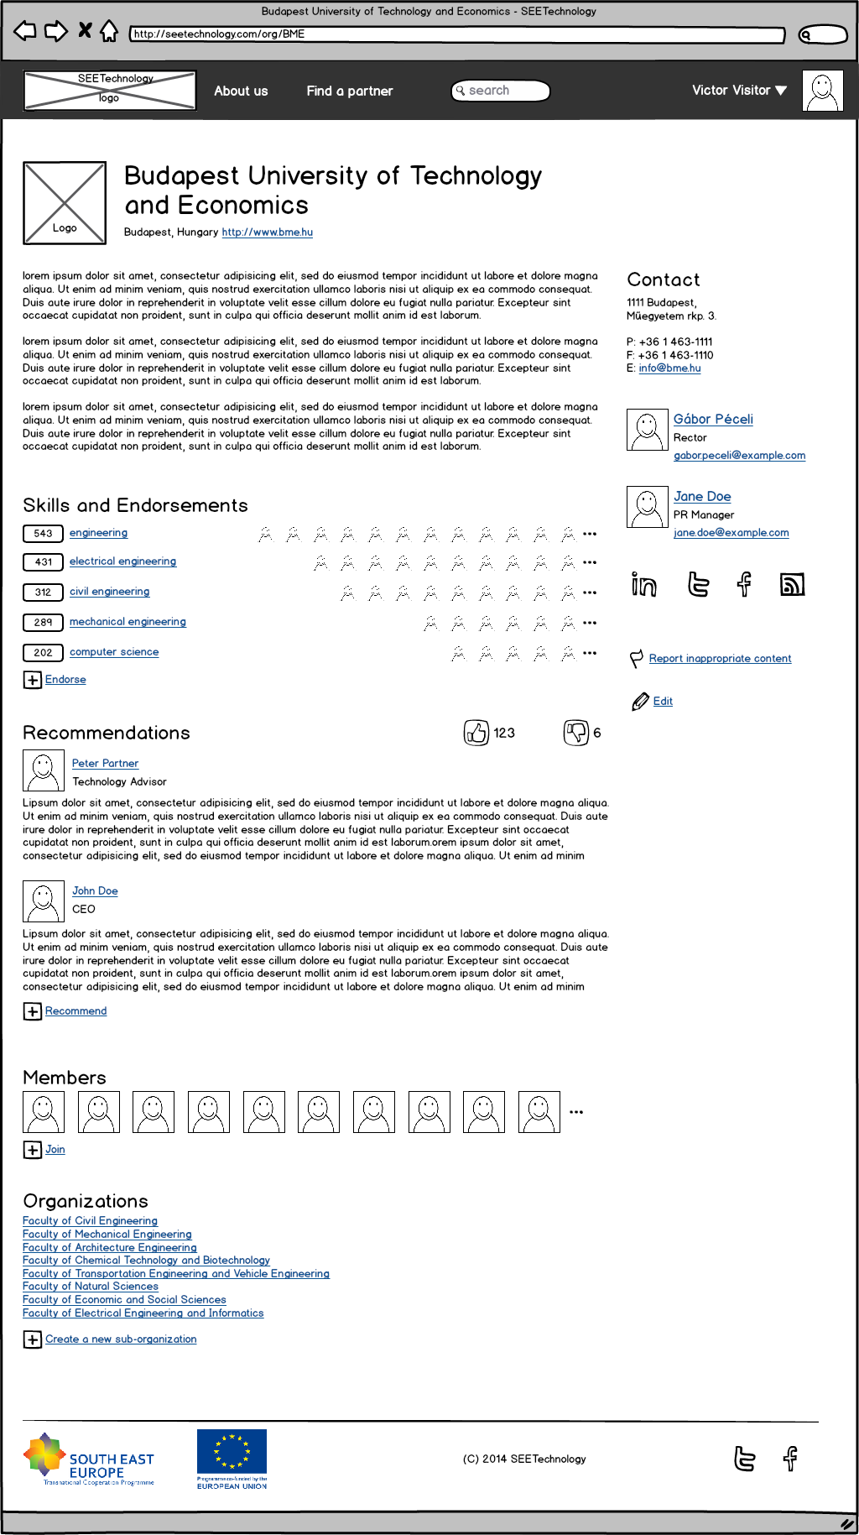

# Common page elements

All pages share a common header and footer.

## Header



The common header has the following elements:

The SEETechnology logo on the left.

The **About us** menu item links to a page which describes the project, the members and the website.

The **Find a partner** menu item links to the browse page which allows manual drill-down by region, tags, etc.

The **Search box** allows free-text search of the full content of the database.

The **personal menu** provides access to edit the currently logged-in user’s profile and change the personal settings.

If the user is not logged-in yet, a **Join or Login** link appears in the upper right corner of the page. The **Join** link shows a modal dialog which explains the user that she must sign-in with her LinkedIn account, and then forwards her to the LinkedIn login page. The **Login** link redirects the user directly to the LinkedIn login page.

(This is just a quick overview of the registration and login procedure from the standpoint of the header, the workflow should be detailed later in another document.)

## Footer



The fat footer can contain the logos of the sponsors, and links to the project’s Facebook and Twitter pages.

# Page body

The middle section of the page consists of a wider main pane on the left, and a sidebar on the right.

## Main pane

The Main pane contains the following sections:

* Title
* Introduction
* Skills and endorsements
* Recommendations
* Members
* Organization

### Title section

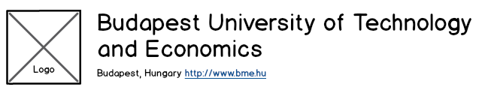

The Title section contains the following elements:

* The 100x100 pixel logo of the organization if uploaded or a generic organization logo.
* The full name of the organization.
* The city and the country of the organization.
* A link to the official website of the organization.

### Introduction section

The introduction section may contain free text which describes the organization. The organization admin may write here about their most important projects, awards, events, etc.

This free text block may contain the following formatting:

* Section headers (which are Level 2 headers in the context of the full page)
* Paragraphs.
* Character formatting for bold, italic and underline.
* Links to external content.
* Numbered and bulleted lists.

Note, that images, videos, tables and rules are not available to ensure consistent look and feel for all organization pages.

### Skills and Endorsements section

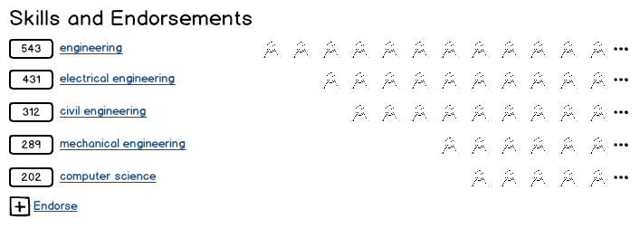

This section mimics similar section in LinkedIn, and its goal is to provide a quick overview of the main skills of the organization. The skills and competencies are represented as tags, and this sections shows the users who agreed that this organization is mastering these skills.

The number of the users are displayed on the left, followed by the name of the tag. The right side of the section contains the last X number of endorsing users. The “…” button links to a page which shows all users who endorsed this organization for the selected tag.

The **Endorse** link on the bottom allows the users to manually endorse this organization. Although the system automatically asks the visitors to endorse the org (like in LinkedIn), this button may help to speed up the process and collect a useful number of endorsements in a short time frame after the site is launched.

### Recommendations section

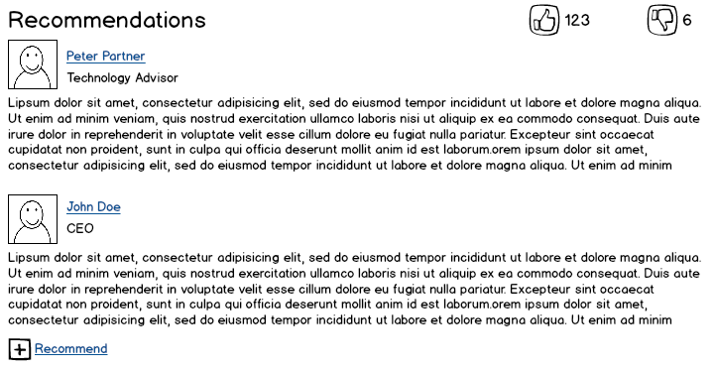

The goal of this section is to display detailed opinions about the organization from real persons.

The section displays a list of recommendations, and every list item has the following elements:

* The photo, name and headline (which are coming from the LinkedIn profile) of the user who wrote the recommendation. The photo and the name link to the user’s LinkedIn profile.
* The text of the recommendation.

Besides the quotes this section contains a **Like** and an **Unlike** buttons which provide an anonymous way to sign the visitors that this organization can or can’t be trusted. These buttons are available also when there are no recommendations yet for the organization. The numbers next to the buttons display the number of up and down votes.

The **Recommend** link on the bottom allows the page visitors to write a recommendation. The recommendation is displayed immediately, but can be moderated by the organization admin any time. Again, this is to speed up the content collection after the site is launched while minimizing the work of the organization admin.

### Members section

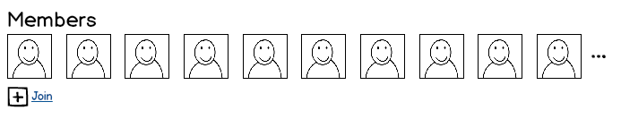

The goal of this section is to display the working members of the organization, because the skills and competencies of the individuals form the skills and competencies of the whole organization.

The section displays the photos of the members with links to their LinkedIn profile page. Only the last X number of members are displayed, and the “…” links to a page which lists all members.

The **Join** button allows the page visitors to join to this organization. When the user clicks this button a modal dialog explains that a join request is sent to the organization admin, and her membership is waiting for approval.

### Organizations section

This section list the organization units of the current organization (e.g. faculties for universities, or research teams for a department).

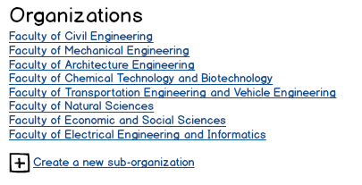

By clicking the name the user can navigate to the profile page of the sub-organization.

The **Create new sub-organization** button allows the user to send a request to the organization admin for a new sub-organization.

## Sidebar

The right sidebar contains the following modules:

* Contact
* Head of the organization
* Organization admin contact
* Social links
* Actions

### Contact section

The Contact section contains the official contact details of the organization with its postal address, phone and fax numbers, and central e-mail address.

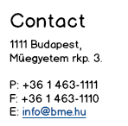

### Head of the organization section

The head of the organization is represented by the basic properties from his LinkedIn profile: his photo, name, headline and e-mail address. The photo and the name links to the LinkedIn profile page.

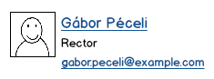

### Organization admin section

The administrator of the organization is displayed on the page with her basic properties from her LinkedIn profile: her photo, name, headline and e-mail address. The photo and the name links to the LinkedIn profile page.

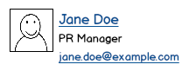

Note that the organization can have multiple administrators.

### Social links section



The social links section displays direct links to the LinkedIn, Twitter and Facebook pages of the organization, and also displays and RSS link to proxy the news from the organization’s own website.

### Actions section

The **Report inappropriate content** allows the visitors to send a notification to the organization and the site admin about the content on the page.

The **Edit** link is displayed only to the organization administrators, and by clicking it she can navigate directly to the organization edit page.